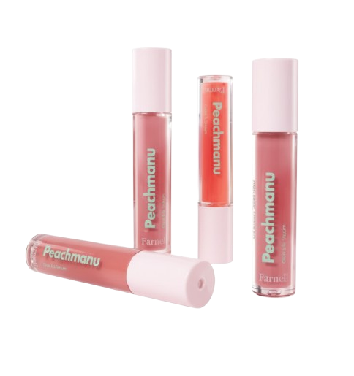
Name : Peachmanu glow lip serum
Description :
A lightweight, hydrating lip serum that gives lips a soft, glossy shine while keeping them smooth and moisturized.
Direction :
Apply a thin layer on your lips anytime you want hydration or shine. Reapply as needed throughout the day.

